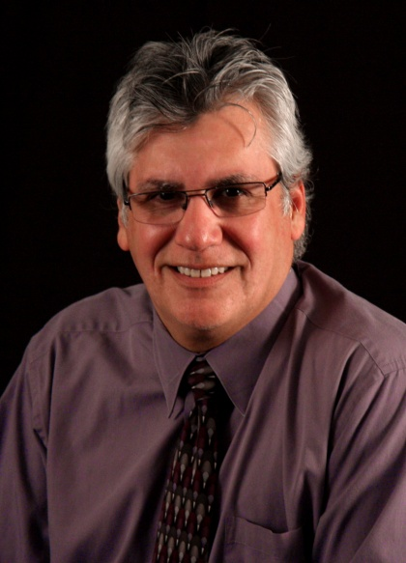
Dr. Vince Rodriguez
Vice President, Instruction and Student Services

Dr. Vince Rodriguez grew up in Orange, California. He graduated from Orange Coast College with an Associate degree and went on to earn a Bachelor of Science degree in Information Technology and a Master of Arts in Education with an emphasis in Distance Learning and Adult Education. In 2011 he completed his dissertation titled “Relationships between Student Characteristics and Student Persistence in Online Classes at a Community College” and earned a doctorate in educational leadership from California State University, Long Beach. Dr. Rodriguez has been a member of the Coast Community College District since 1998 and has worked as a classified employee, instructor, and administrator. During his 14 years at Coastline, he provided leadership at each of Coastline’s learning centers and spent many years overseeing a Distance Learning program that accounts for nearly half of the enrollments at the College. Dr. Rodriguez is a resident of Huntington Beach and in his free time, volunteers as a coach and referee for the Costa Mesa region of the American Youth Soccer Organization (AYSO).

